

**School of Mechanical & Manufacturing Engineering (SMME),**

**National University of Science and Technology (NUST)**

**Program**: BE-Aerospace

**Semester**: 2nd

**Session**: Spring 2024

**Course Code**: AE-103

**Engineering drawing Assignment no #1**

**NAME:** Rana Asim Nadeem

**CMS ID:** 481209

**Orthographic Projection:**

Figure no 1:

Front view

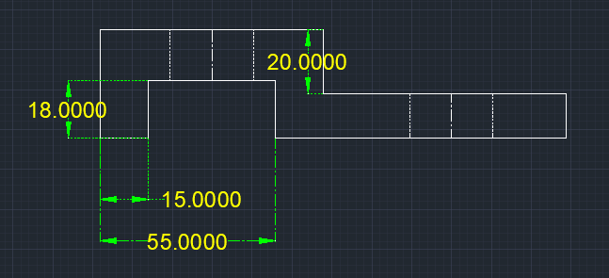

Side view

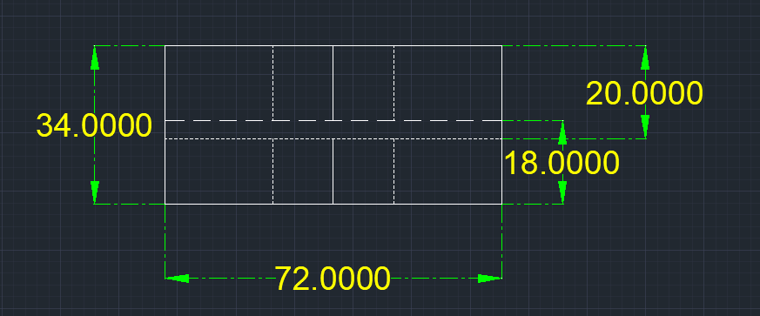

Top view

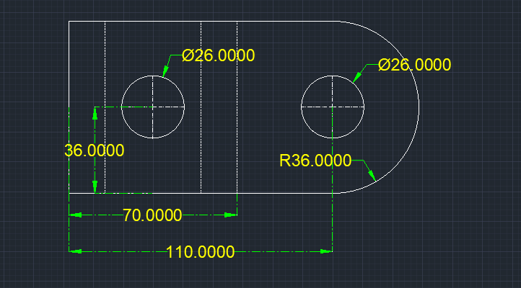

Figure No 2:

Front view

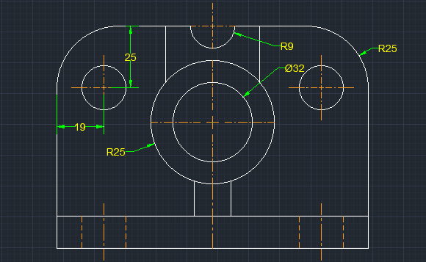

Side view

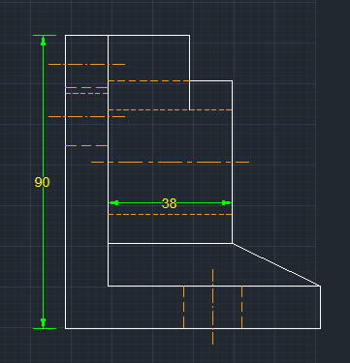

Top view

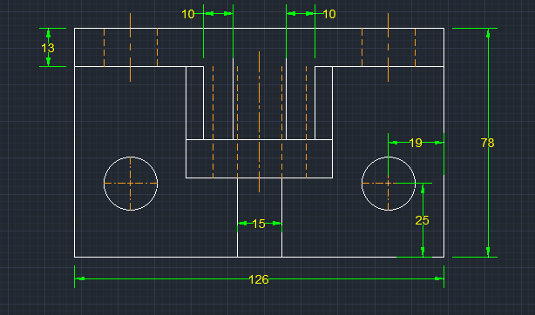

Figure no 3:

Front view

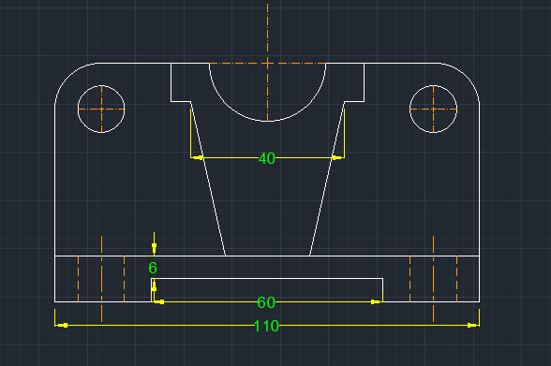

Side view

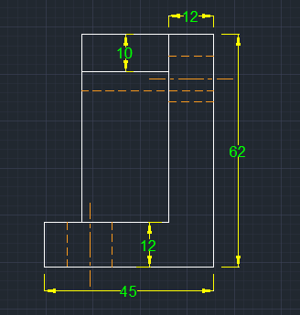

Top view

